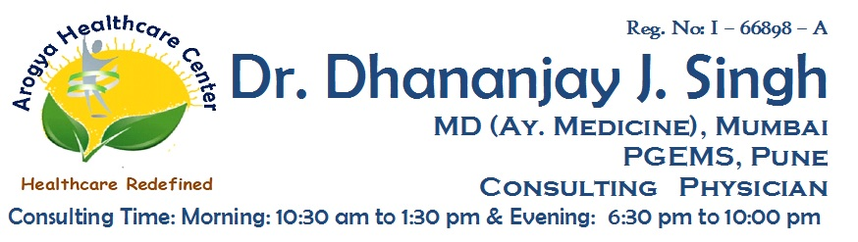

**Reg No: I-66898-A**

**Dr. Dhananjay J. Singh**

**MD (MEDICINE AY.) MUMBAI, PGEMS CONSULTING PHYSICIAN**

Date : 14 / 10 / 2020

**MEDICAL CERTIFICATE**

**To Whomsoever It May Concern**

This is to Certify that

**Mr. Dinesh Bhawarlal Purohit** , Male / 38 Years taking treatment

for ? Viral fever under my observation at **Arogya Healthcare Center**.

He is taking treatment since 12-Oct-2020. He is showing symptoms like

Influenza. Presently, he is lethargic and feeling very weak. Further

investigations will be required to conclude on final diagnosis. On

considering present ill status of patient, he is advised to take bedrest for

7 Days Or till he gets cured.

**Dr. Dhananjay J. Singh**

**Note :**

1. Please bring this paper on every visit. 3. Don’t substitute any medicine without consultation.
2. This prescription cannot be used for medico-legal purpose. 4. Please confirm medicines with doctor before use.

**Address :** Shop No:3, Rosewood Building, Orchid Residency, Charnipada, Bhiwandi, Dist - Thane

**For Appointment** : +91 9967 134 911 | **In Case Of Emergency** : +91 9762 266 021